

**Capstone Project**

**(University DataBase Management System)**

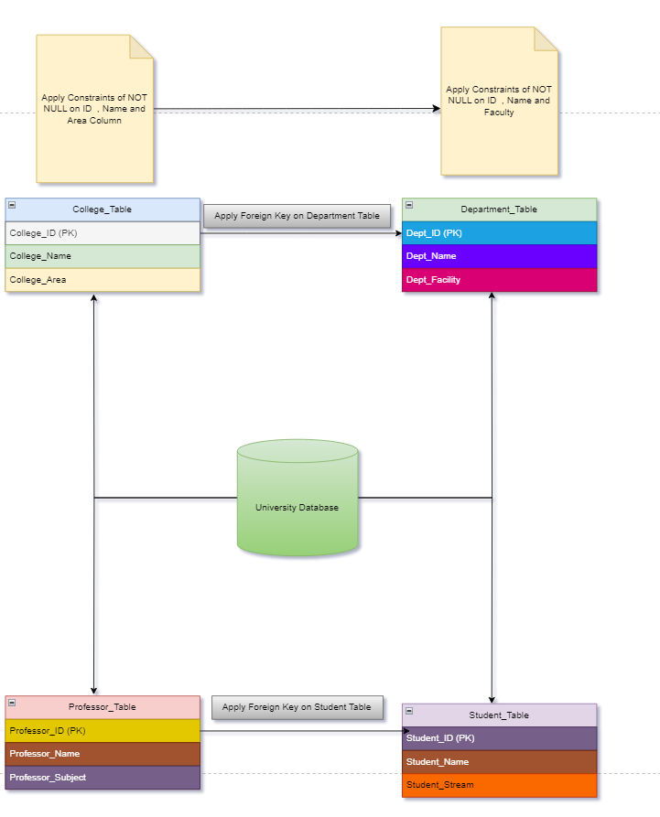

University Database Management System is one of the Fundamental and Intermediate level SQL project

Here in this Project you have to create an efficient DBMS for the any University .

Inorder to create this system Perform the following task:-

**Task 1:-**

1.Create University Database give any University name you want

Create Database **Dayanand Sagar University**

Create table College_Table(College_ID Int Primary Key,College_Name Varchar(25),College_Area Varchar(25))

INSERT INTO College_Table (College_ID, College_Name, College_Area) VALUES

(1, 'SBR College', 'Area1'),

(2, 'LVD College', 'Area2'),

(3, 'Nitti College', 'Area3'),

(4, 'RV College', 'Area4'),

(5, 'Reva College', 'Area5'),

(6, 'Vevakananda College', 'Area6'),

(7, 'SLN College', 'Area7'),

(8, 'Govt College', 'Area8'),

(9, 'RIMS College', 'Area9'),

(10, 'Ramaya College', 'Area10');

CREATE TABLE Department_Table (

Dept_ID INT,

Dept_Name VARCHAR(25),

Dept_Facility VARCHAR(25),

FOREIGN KEY (Dept_ID) REFERENCES College_Table(College_ID)

);

INSERT INTO Department_Table (Dept_ID, Dept_Name, Dept_Facility) VALUES

(1, 'Computer Science', 'Innovation Hub'),

(2, 'Mechanical Engineering', 'Workshop'),

(3, 'Electrical Engineering', 'Power Systems Lab'),

(4, 'Civil Engineering', 'Surveying Lab'),

(5, 'Biology', 'Research Greenhouse'),

(6, 'Chemistry', 'Analytical Lab'),

(7, 'Physics', 'Optics Lab'),

(8, 'Mathematics', 'Problem-Solving Room'),

(9, 'Business Administration', 'Business Incubator'),

(10, 'Psychology', 'Counseling Center');

Create Table Professor_Table(Professor_ID Int Primary Key,Professor_Name Varchar(25),Professor_Subject varchar(25))

INSERT INTO Professor_Table (Professor_ID, Professor_Name, Professor_Subject) VALUES

(1, 'John Smith', 'Computer Science'),

(2, 'Jane Doe', 'Mechanical Engineering'),

(3, 'David Johnson', 'Electrical Engineering'),

(4, 'Emily Wilson', 'Civil Engineering'),

(5, 'Michael Brown', 'Biology'),

(6, 'Sarah Taylor', 'Chemistry'),

(7, 'Christopher Lee', 'Physics'),

(8, 'Jennifer Clark', 'Mathematics'),

(9, 'Daniel Martinez', 'Business Administration'),

(10, 'Jessica White', 'Psychology');

CREATE TABLE Student_Table (

Student_ID INT PRIMARY KEY,

Professor_ID INT,

Student_Name VARCHAR(25),

Student_Stream VARCHAR(25),

FOREIGN KEY (Professor_ID) REFERENCES Professor_Table(Professor_ID))

INSERT INTO Student_Table (Student_ID, Professor_ID, Student_Name, Student_Stream) VALUES

(1, 1, 'Alice', 'Computer Science'),

(2, 2, 'Bob', 'Mechanical Engineering'),

(3, 3, 'Charlie', 'Electrical Engineering'),

(4, 4, 'Diana', 'Civil Engineering'),

(5, 5, 'Eve', 'Biology'),

(6, 6, 'Frank', 'Chemistry'),

(7, 7, 'Grace', 'Physics'),

(8, 8, 'Henry', 'Mathematics'),

(9, 9, 'Ivy', 'Business Administration'),

(10, 10, 'Jack', 'Psychology');

**Task 2:-**

--1. Give the information of College_ID and College_name from College_Table

Select College_ID,College_Name from College_Table

-- 2. Show Top 5 rows from Student table.

Select top 5 * from Student_Table

--3. What is the name of professor whose ID is 5

Select Professor_Name from Professor_Table where Professor_ID=5

--4. Convert the name of the Professor into Upper case

Select Professor_Name,Upper(Professor_Name) as Capital_Name from Professor_Table

--5. Show me the names of those students whose name is start with a

Select Student_Name From Student_Table where Student_Name like 'a%'

--6. Give the name of those colleges whose end with a

Select College_Name from College_Table where College_Name like '%a'

--7. Add one Salary Column in Professor_Table

Alter Table Professor_Table

Add Salary Decimal(10,2)

Select *from Professor_Table

UPDATE Professor_Table

SET Salary =

CASE Professor_ID

WHEN 1 THEN 100000.00

WHEN 2 THEN 200000.00

WHEN 3 THEN 300000.00

WHEN 4 THEN 400000.00

WHEN 5 THEN 500000.00

WHEN 6 THEN 600000.00

WHEN 7 THEN 700000.00

WHEN 8 THEN 800000.00

WHEN 9 THEN 900000.00

WHEN 10 THEN 1000000.00

END

--8. Add one Contact Column in Student_table

Alter Table Student_table

Add Contact Int

Select * from Student_Table

--9. Find the total Salary of Professor

Select Sum(Salary) Total_Salary from Professor_Table

--10. Change datatype of any one column of any one Table

Alter Table College_Table

Alter Column College_Name Char(25)

**Task 3:-**

--1. Show first 5 records from Students table and Professor table Combine

Select Top 5 * from Student_Table Inner Join

Professor_Table ON

Student_Table.Student_ID=Professor_Table.Professor_ID

--2. Apply Inner join on all 4 tables together

SELECT *

FROM College_Table AS Col

INNER JOIN Department_Table AS Dept ON Col.College_ID = Dept.Dept_ID

INNER JOIN Professor_Table AS Prof ON Dept.Dept_ID = Prof.Professor_ID

INNER JOIN Student_Table AS Stu ON Prof.Professor_ID = Stu.Professor_ID

--3. Show Some null values from Department table and Professor table.

-- For Department_Table

SELECT *

FROM Department_Table

WHERE Dept_Name IS NULL

-- For Professor_Table

SELECT *

FROM Professor_Table

WHERE Professor_Name IS NULL

--4. Create a View from College Table and give those records whose college name starts with C

CREATE VIEW College_C_Records AS

SELECT *

FROM College_Table

WHERE College_Name LIKE 'C%';

SELECT * FROM College_C_Records;

--5. Create Stored Procedure of Professor table whatever customer ID will be given by user it should show whole records of it.

CREATE PROCEDURE GetProfessorByID

@ProfessorID INT

AS

BEGIN

SELECT *

FROM Professor_Table

WHERE Professor_ID = @ProfessorID;

END;

EXEC GetProfessorByID @ProfessorID = 5;

Select * from Professor_Table

--6. Rename the College_Table to College_Tables_Data .

EXEC sp_rename 'College_Table', 'College_Tables_Data';

Select * From College_Tables_Data